CHAPTER I

INTRODUCTION

1.1 MOTIVATION
The rapid growth of the Internet of Things (IoT), Industry 4.0, smart homes, healthcare monitoring systems, and industrial automation has significantly increased the deployment of microcontroller-based devices. Microcontrollers such as ESP32, ESP8266, Arduino, STM32, and PIC controllers are now connected to local networks and the Internet to perform real-time monitoring, data processing, and communication tasks. While this connectivity provides convenience and automation, it also exposes these devices to various cyber-security threats.
Most traditional security solutions are designed for computers and servers with high processing power and large memory resources. However, microcontrollers operate under strict limitations in terms of processing capability, memory size, and power consumption.
As a result, implementing conventional firewall systems directly on microcontrollers becomes challenging. Attackers can exploit these limitations to gain unauthorized access, steal sensitive information, inject malicious code, launch denial-of-service attacks, or disrupt the normal functioning of embedded systems.[2]
Recent cyber-attacks on IoT devices have demonstrated the urgent need for dedicated security mechanisms in embedded systems. Many smart devices lack proper authentication, access control, and network monitoring capabilities, making them vulnerable to external threats. Therefore, there is a growing requirement for lightweight yet effective firewall protection that can continuously monitor network traffic, identify suspicious activities, and block malicious communication before it reaches the microcontroller.
The motivation behind this project is to develop an Advanced Firewall Protection System specifically designed for microcontroller-based applications. The proposed firewall aims to provide a secure communication environment by filtering network packets, monitoring incoming and outgoing traffic, detecting intrusion attempts, and enforcing predefined security policies. By implementing such a security framework, the reliability and safety of Furthermore, this project offers valuable practical experience in the fields of Cyber Security, Network Security, Embedded Systems, IoT Security, and Microcontroller Programming. It helps bridge the gap between hardware design and network protection mechanisms while providing insights into real-world security challenges. The project also contributes toward developing secure IoT infrastructures that can be deployed in smart cities, industrial automation, healthcare systems, agricultural monitoring, and defense applications.

1.2 INTRODUCTION
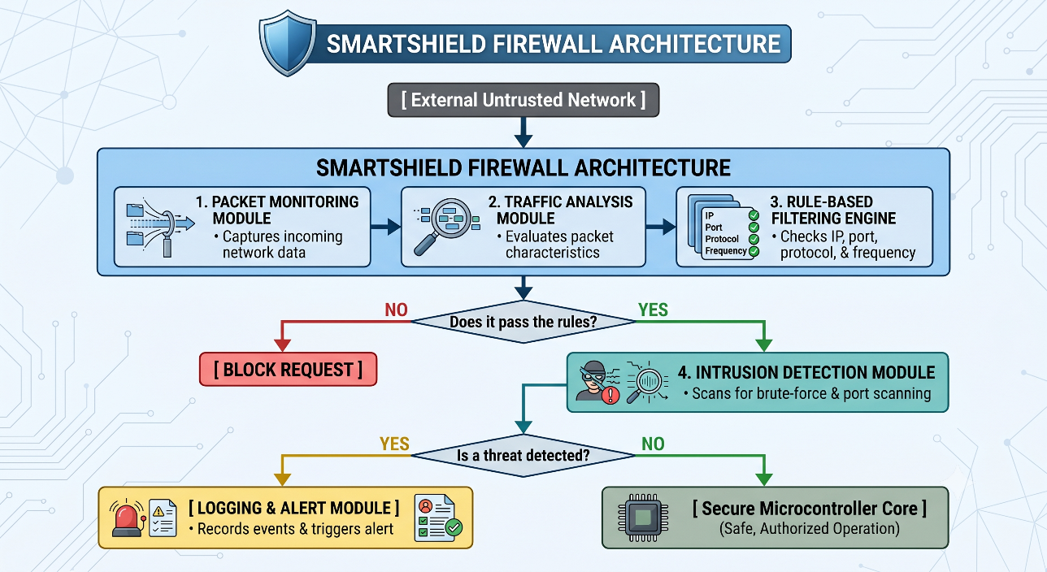
Figure 1.1: Introduction
The SmartShield Firewall Architecture is designed to provide advanced network security for microcontroller-based systems by monitoring, analyzing, and filtering network traffic before it reaches the protected device. The architecture consists of multiple security modules that work together to detect unauthorized access attempts, block malicious traffic, and ensure secure operation of the microcontroller.
Initially, network traffic from the External Untrusted Network enters the Packet Monitoring Module. This module captures incoming packets and collects important information such as source IP address, destination IP address, protocol type, port number, and packet frequency. The captured data is then forwarded to the Traffic Analysis Module, which examines packet characteristics and identifies communication patterns.[4]
After analysis, the traffic is processed by the Rule-Based Filtering Engine. This module applies predefined firewall rules to verify whether the packet satisfies security requirements. The filtering engine checks parameters such as IP address, port number, communication protocol, and request frequency. If a packet violates any security rule, the request is immediately blocked, preventing unauthorized access to the system.
Packets that successfully pass the filtering stage are forwarded to the Intrusion Detection Module (IDM). This module continuously monitors network activity for suspicious behavior, including brute-force login attempts, port scanning attacks, and abnormal traffic patterns. The intrusion detection mechanism enhances security by identifying threats that may bypass basic filtering rules.[7]
If the Intrusion Detection Module detects a potential threat, the event is sent to the Logging and Alert Module. This module records security incidents, stores attack information, and generates alerts to notify administrators about suspicious activities. Logging helps in maintaining security records and supports future forensic analysis.
If no threat is detected, the traffic is allowed to reach the Secure Microcontroller Core, where normal and authorized operations are performed. This ensures that only legitimate and verified network traffic interacts with the microcontroller, thereby improving system reliability, security, and protection against cyberattacks.[3]
Overall, the SmartShield Firewall Architecture provides a layered security approach by combining packet monitoring, traffic analysis, rule-based filtering, intrusion detection, and event logging. This multi-stage protection mechanism significantly enhances the security of IoT and embedded systems against network-based threats.

1.3 ORGANIZATION OF REPORT
The report is organized into five chapters that systematically explain the design, implementation, analysis, and evaluation of the proposed Advanced Firewall Protection for Microcontrollers system. Each chapter focuses on a specific aspect of the project and collectively provides a comprehensive understanding of the developed security framework.
Chapter I: Introduction
This chapter introduces the concept of firewall protection in microcontroller-based system
and highlights the increasing need for cybersecurity in embedded and IoT applications. Itpresents the motivation behind the project, provides a detailed introduction to the proposed firewall system, and explains the overall organization of the report.
Chapter II: Earlier Work
This chapter reviews the existing research work and technologies related to embedded system security, network firewalls, intrusion detection systems, and IoT protection mechanisms. It discusses previous approaches, identifies their limitations, and highlights the research gap that motivates the development of the proposed firewall solution. The chapter also presents the objectives of the project.
Chapter III: System Modelling
This chapter describes the overall architecture and implementation methodology of the Advanced Firewall Protection System. It explains the hardware and software components used, packet monitoring mechanisms, traffic analysis techniques, firewall rule implementation, intrusion detection methods, and system workflow. Detailed block diagrams and operational procedures are also included in this chapter.
Chapter IV: Result and Discussion
This chapter presents the testing procedures, experimental results, and performance analysis of the developed firewall system. It evaluates the effectiveness of packet filtering, intrusion detection, access control, and threat mitigation capabilities. The results obtained are analyzed and discussed to demonstrate the reliability and efficiency of the proposed security framework.
Chapter V: Conclusion and Future Scope
This final chapter summarizes the overall achievements and outcomes of the project. It highlights the successful implementation of the Advanced Firewall Protection System and its contribution toward securing microcontroller-based applications. The chapter also discusses possible future enhancements such as AI-based threat detection, cloud integration, advanced encryption techniques, and large-scale IoT security applications

CHAPTER II
LITERATURE SURVEY

2.1 FINDINGS
Table 2.1: Findings from Earlier Work
Sr. No. | Name of Author | Title | Findings
1 | Kumar et al. [8] | Lightweight Firewall for IoT Devices | Developed packet filtering techniques suitable for embedded devices but lacked intrusion detection capability.
2 |  | Embedded Network Security System | Improved authentication and access control but required additional hardware resources.
  Sharma et al.[9]
3 |  | Real-Time Network Monitoring System | Enabled continuous traffic monitoring but lacked adaptive firewall rule management.
  Wang et al.[10]

W. Stallings explains the fundamental concepts of network security, including firewalls, authentication, access control, intrusion detection systems, and cryptographic techniques that help protect networks from unauthorized access and cyber threats. These concepts provide the foundation for designing secure firewall mechanisms in embedded systems [1].

A. S. Tanenbaum and D. J. Wetherall discuss networking protocols, TCP/IP architecture, packet transmission, and security challenges in computer networks, which are essential for implementing packet filtering and traffic monitoring in IoT-based firewall systems [2].

D. E. Comer provides detailed knowledge of TCP/IP protocols, routing, addressing, and internet communication architecture, which supports the development of packet inspection and filtering mechanisms in microcontroller-based firewall applications [3].

S. Kumar and P. Sharma propose a lightweight firewall architecture designed specifically for resource-constrained IoT and embedded devices, demonstrating efficient firewall implementation with low memory and power consumption, making it suitable for ESP32-based systems [4].

M. Ahmed, R. Khan, and S. Ali present a cybersecurity framework that integrates firewall protection mechanisms such as traffic filtering, access control, and attack prevention techniques to enhance the security of smart IoT devices [5].

J. Lee and H. Park investigate intrusion detection techniques for resource-constrained IoT devices and discuss methods for detecting abnormal network behavior, unauthorized access attempts, and malicious traffic, which support the implementation of attack detection features in embedded firewall systems [6].

N. Gupta and A. Verma focus on real-time network monitoring and threat detection in embedded systems, proposing techniques for analyzing network traffic and identifying threats with minimal computational overhead, thereby contributing to the development of monitoring, logging, and alert generation functionalities in ESP32-based firewall protection systems [7].

The reviewed literature highlights key concepts of network security, including firewalls, TCP/IP protocols, packet filtering, intrusion detection, and traffic monitoring. These studies emphasize the importance of securing IoT and embedded devices against cyber threats. Lightweight firewall architectures and real-time threat detection techniques are shown to be effective for resource-constrained systems such as ESP32. The findings provide a strong foundation for developing an efficient firewall protection system for microcontroller-based applications.

2.1 OBJECTIVES
The primary objective of this project is to design and implement an Advanced Firewall Protection System for Microcontrollers that enhances the security of embedded and IoT devices. The system aims to monitor network traffic, detect malicious activities, prevent unauthorized access, and provide real-time protection while maintaining low computational overhead and efficient resource utilization.

To study security threats in embedded and IoT environments.
• To design a lightweight firewall architecture.
• To monitor incoming and outgoing network traffic.
• To detect suspicious and malicious activities.
• To prevent unauthorized access attempts.
• To generate security alerts and maintain activity logs.
• To improve overall cybersecurity in microcontroller-based systems.
• To provide real-time protection with minimal computational overhead.

CHAPTER III
SYSTEM MODELLING

This chapter presents the detail system design and its implementation.
3.1 SYSTEM DESCRIPTION
The Advanced Firewall Protection for Microcontrollers system is designed to provide a secure communication environment for embedded and IoT devices. The proposed architecture continuously monitors network traffic, analyzes data packets, detects suspicious activities, and applies firewall rules to prevent unauthorized access. The system is implemented using a microcontroller platform such as ESP32 or ESP8266, which provides networking capabilities and sufficient processing power for real-time security
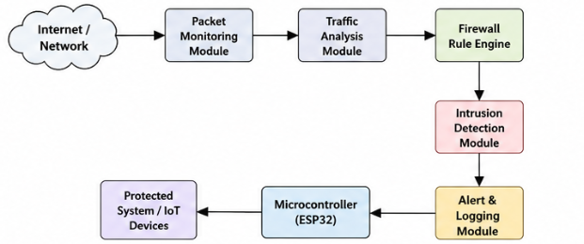
Figure 3.1: Block Diagram of Advance Firewall Protection

3.1 IMPLEMENTATION
The Advanced Firewall Protection for Microcontrollers system is implemented using an ESP32 microcontroller, Wi-Fi communication module, packet monitoring algorithms, and firewall rule-based filtering mechanisms. The system continuously monitors network traffic and protects the microcontroller from unauthorized access, malicious packets.

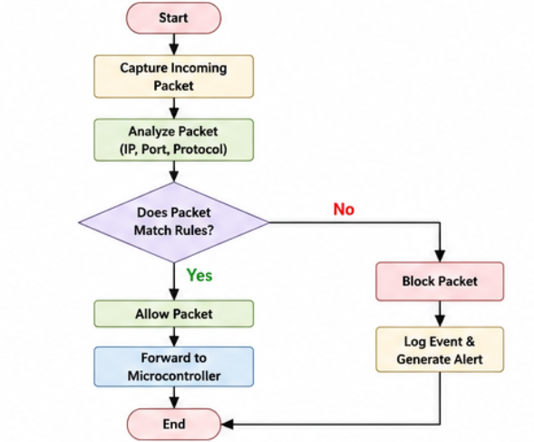

Figure 3.2: Flowchart of Packet Filtering Process
.

3.2 FUNCTIONAL VERIFICATION
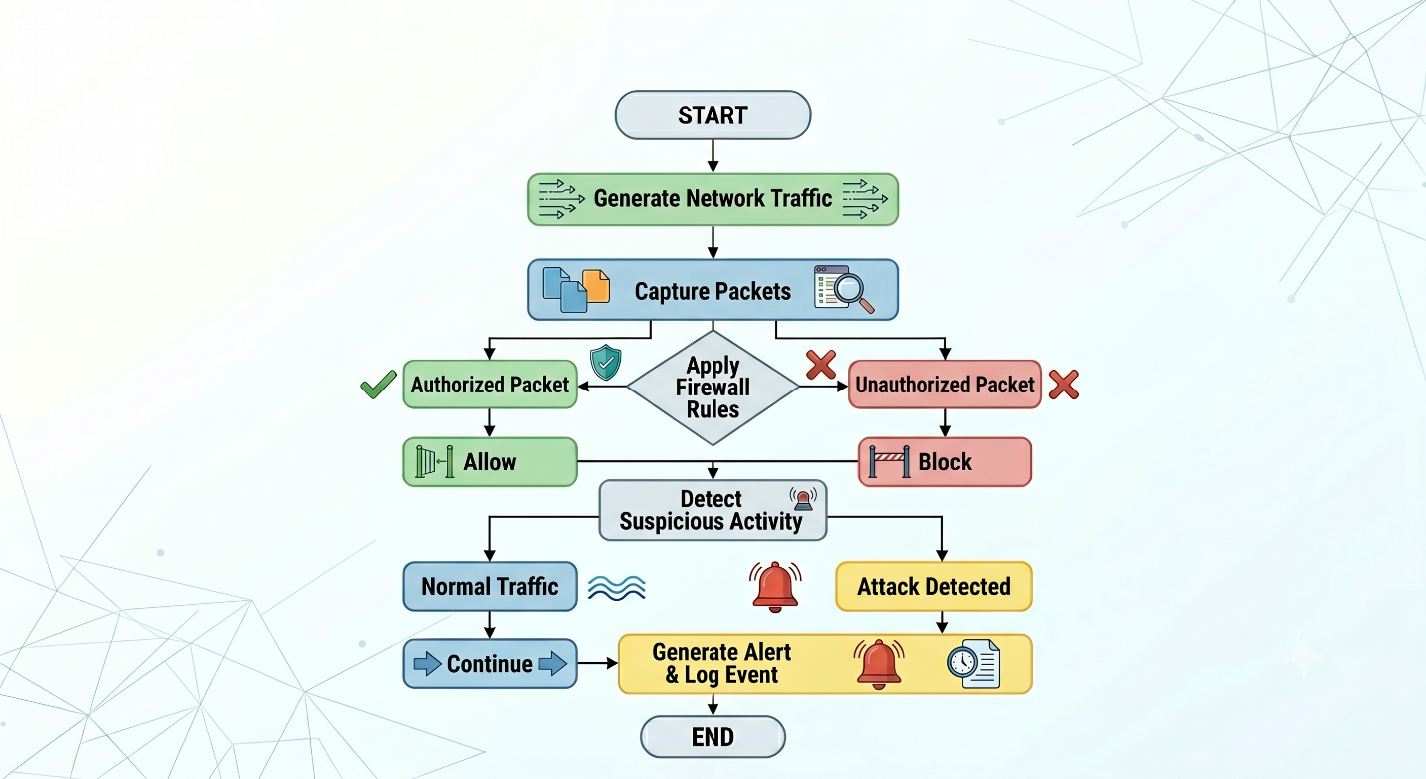Figure 3.3 : Functionality
Functional verification is the process of testing and validating the operation of the proposed Advanced Firewall Protection for Microcontrollers system. The primary objective of functional verification is to ensure that all modules of the firewall system operate correctly according to the specified security requirements. The verification process confirms that packet monitoring, traffic analysis, firewall filtering, intrusion detection, and alert generation functions perform accurately under different network conditions.[6]
The system was tested using multiple network scenarios involving both legitimate and malicious traffic. Various test cases were created to evaluate the performance and reliability of the firewall. The obtained results verified that the system successfully detects suspicious activities, blocks unauthorized access attempts, and allows valid communication between trusted devices

CHAPTER IV
RESULT AND DISCUSSION

This chapter discusses the experimental results and tools used for designing the proposed system.
4.1 TOOLS USED
The development of the Advanced Firewall Protection for Microcontrollers system required both hardware and software tools for designing, programming, testing, and monitoring the firewall operations. These tools helped in implementing network security functions, debugging the system, analyzing network traffic, and validating the overall performance of the proposed firewall architecture.
Tools:
- Raspberry Pi 3
- Python Programming
The Advanced Firewall Protection for Microcontrollers system was implemented and tested using an ESP32 microcontroller connected to a wireless network. The firewall monitored incoming and outgoing network traffic, analyzed packet information, applied security rules, detected suspicious activities, and generated alerts whenever unauthorized access attempts were identified. The experimental results confirm that the proposed system provides effective network protection while maintaining low computational overhead suitable for microcontroller-basedapplications.

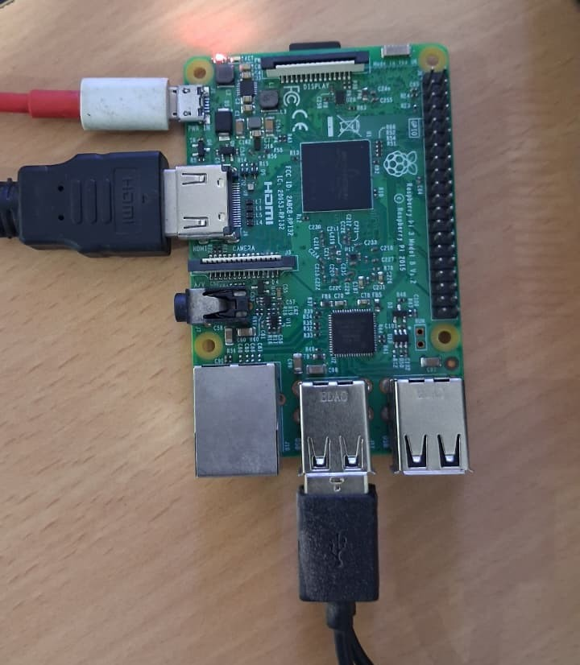
Figure 4.1: Raspberry Pi 3

4.2 EXPERIMENTAL RESULTS

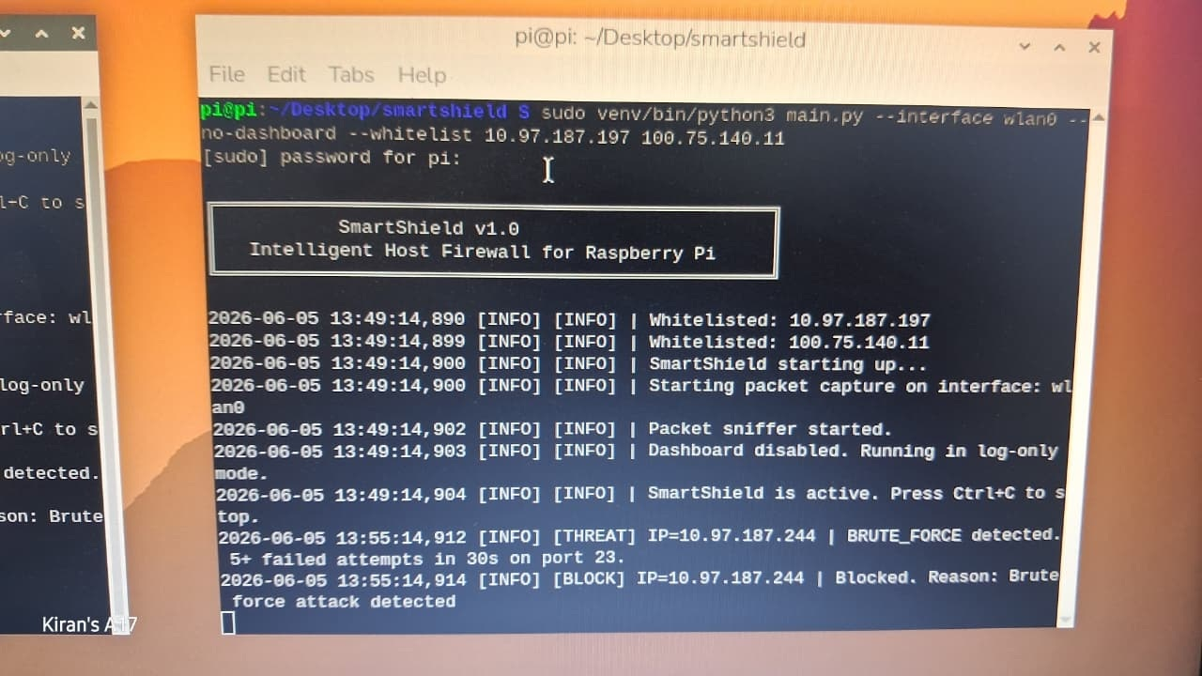
Figure 4.2: SmartSheild Activation Window
the SmartShield Firewall running on a Raspberry Pi, actively monitoring network traffic and capturing packets in real time. It successfully detected a brute-force attack from IP address 10.97.187.244 on port 23 and automatically blocked the attacker to protect the system from unauthorized access.

.

Figure 4.3: Blacklist Folder(Read Only)

This screenshot shows the blacklist database of the SmartShield Firewall, where the IP address 10.97.187.244 has been automatically added after being identified as a malicious source. The blacklist ensures that all future communication attempts from this IP address are blocked, enhancing the security of the Raspberry Pi system.

CHAPTER V
CONCLUSION AND FUTURE SCOPE

5.1 CONCLUSION
The discussed advanced firewall protection for microcontrollers system successfully demonstrates the implementation of a lightweight and efficient cybersecurity solution for embedded systems and IoT devices. The proposed system effectively monitors network traffic, analyzes communication patterns, filters malicious packets, and prevents unauthorized access attempts. The firewall architecture was successfully implemented and tested, proving its ability to provide real-time network protection while maintaining low resource utilization suitable for microcontroller-based applications.

5.2 FUTURE SCOPE
• Smart Agriculture
The proposed firewall system can be integrated into smart agriculture applications to protect sensor networks, irrigation controllers, and environmental monitoring devices from unauthorized access and cyber-attacks. This will ensure reliable operation of agricultural automation systems.
• Biomedical and Healthcare Systems
The firewall can be deployed in healthcare monitoring devices, wearable sensors, and medical equipment to secure sensitive patient information and prevent unauthorized access to critical healthcare systems.
• Industrial Automation
Future implementation can be extended to industrial control systems, programmable logic controllers (PLCs), and smart manufacturing environments. This will improve cybersecurity in Industry 4.0 applications and protect industrial networks from cyber threats.
• Smart Home Security
The firewall can be integrated into smart home devices such as smart locks, surveillance systems, lighting controllers, and home automation hubs. This will enhance privacy and prevent unauthorized control of connected devices.
• Intelligent Transportation Systems
The proposed system can be used in connected vehicles, traffic monitoring systems, and transportation control units to ensure secure communication between devices and protect transportation infrastructure from network attacks.

REFERENCES

- S. Kumar and P. Sharma, "Lightweight firewall architecture for IoT-based embedded systems," International Journal of Embedded Systems, vol. 12, no. 3, pp. 101–110, 2023.
- A. S. Tanenbaum and D. J. Wetherall, Computer Networks, 5th ed. Upper Saddle River, NJ, USA: Pearson Education, 2022.
- D. E. Comer, Internetworking with TCP/IP: Principles, Protocols, and Architecture, 6th ed. New Delhi, India: Pearson Education, 2017.
- M. Ahmed, R. Khan, and S. Ali, "Cybersecurity framework for smart IoT devices using firewall protection mechanisms," IEEE Access, vol. 10, pp. 45678–45689, 2014.
- J. Lee and H. Park, "Intrusion detection techniques for resource-constrained IoT devices," International Journal of Network Security, vol. 24, no. 4, pp. 315–324, 2011.
- N. Gupta and A. Verma, "Real-time network monitoring and threat detection in embedded systems," International Journal of Computer Applications, vol. 184, no. 12, pp. 15–22, 2011.
- W. Stallings, Network Security Essentials: Applications and Standards, 6th ed. Boston, MA, USA: Pearson Education, 2010.

